The Academic Progress Report (APR) is a degree audit tool that displays the academic requirements needed to graduate, including those the student has already completed and those not yet completed. While the APR will automatically update when triggered by certain events, you may need to manually update a students’ APR upon request.

Use this reference to manually update a student’s Academic Progress Report (APR).

A. Overview on APR Updates
B. How to Manually Update the APR

Overview on APR Updates
The APR is not updated in real time. Instead, it is updated two ways: 1) Automatically when triggered by specific events and business processes (see list below); 2) When an advisor conducts the Launch Academic Progress Evaluation action in the student account. The day/time of the last update is in the Last Evaluated field.
In the example above, the student’s academic progress report was last updated on 1/31/2024. This means completed hours, grades, and other details are current up until this date. Some activities since this date may not be reflected in the report.

Below is a list of events that will trigger the APR to update automatically.

Academic Progress Report Evaluation Triggers
Triggering events and business processes: |  | When the update occurs
 | Assign student grades | Immediate
 | Change program of study | Immediate
 | Change student grades | Immediate
 | Override academic requirement | Immediate
 | Override requirement effective date | Immediate
 | Transfer credit evaluation | Immediate
 | Add or remove program of study | Nightly
 | Matriculation | Nightly
 | Registration add/drop/withdraw | Nightly

B. How to Manually Update the APR

- To manually update a student’s Academic Progress Report, open the student’s record.

- Click “Actions” on the student record.

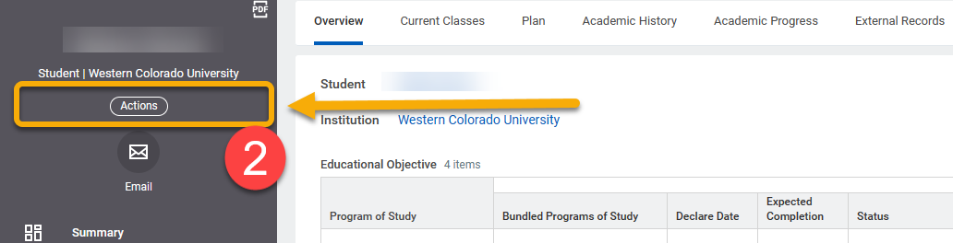

- Click “Advising”.

- Click “Launch Academic Progress Evaluation”. The student’s academic progress report will immediately update and create a new timestamp in the Last Evaluated field.

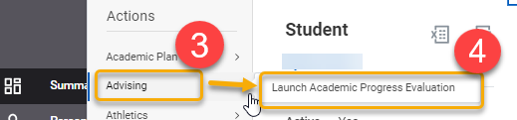

TIP: If a student is concerned about coursework not represented on this report, glance at the Last Evaluated timestamp. It is possible their report has not been updated to reflect changes to their APR.

TIP: If you do not see the “Advising” button in the student record, you may not have access to advising activities in Workday.

